Targeted Hot Spot

Created By: Doug Orbin
Created On: 04/04/2016

Last Updated By: Jessie Perez
Last Update Date: 10/18/2016

Location: 75th Street Corridor 05-01-16
Type: DDACTS
Shift: Days; Eves; Mids

Target Times: 06:00 - 10:00; 18:00 - 24:00

Status: Active

Map:
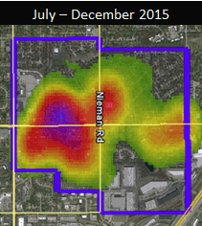

Analysis:
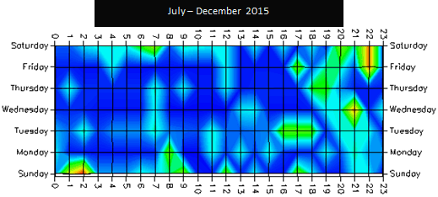
DDACTS 2016 New Target Times - 75 Street.pdf

Operational Plan:
Our primary goal is to reduce and/or maintain the incidences of crime and traffic crashes in our community, specifically three designated DDACTS areas, thereby reducing social harm primarily through high visibility traffic enforcement and pedestrian contacts. To accomplish this, we will strive to achieve 4 contacts per hour in these DDACTS areas a minimum of 10 hours per area/per week during the target times, accomplishing the 10 hour goal a minimum of 85% of the time.
Effective Date
May 1st, 2016
Target Times: Monday through Sunday
0600 - 1000 hours

1800 - 2400 hours

Criminal Interdiction Unit Goals and Objectives
1) CIU, as a unit, will support the department's DDACTS practice by auditing target times throughout each week and directing themselves based on need within each area.
2) Each CIU officer will spend 1 hour per day in one DDACTS area per shift worked by auditing target times throughout each week and directing themselves based on need within each area.
3) Individual goal is to attain 1 contact every 15 minutes.

Traffic Safety Unit Goals and Objectives
1) Each TSU officer will spend 30 minutes per day in one DDACTS area per shift worked by auditing target times throughout each week and directing themselves based on need within each area.
2) Goal is to attain 1 contact every 15 minutes.
Road Patrol Goals and Objectives
1) The shift supervisor shall assign District 2, 30 minutes per shift during the Target Times conducting high visibility enforcement in this DDACTS area.
2) When staffing is above minimums, officers not assigned to a district are expected to self-direct into the DDACTS areas as time allows.
3) Districts 5 and 6 shall remain west of Renner road unless directed to move center due to a high call load in the eastern districts of the City.
4) Any other available district cars or 95 (Back-up) units may self-direct enforcement in the DDACTS area.
5) Goal for all Road Patrol officers is to attain 1 contact per every 15 minutes when in the DDACTS area.
DDACTS Enforcement Strategies
1) High Visibility Traffic Enforcement will be conducted with lower discretionary levels than what has traditionally been accepted as the norm when determining if a citizen contact is necessary. The key to reducing crime and traffic crashes is to make high visibility contacts (emergency lights activated). When self-initiated activity increases, the incidences of crime and traffic crashes decrease, thereby reducing social harm. Tickets should be written when officer discretion deems it appropriate considering the nature of the violation; however, written warnings are entirely appropriate when considering the lower discretionary levels and should be considered accordingly.
2) When an officer deploys to the DDACTS area, he/she shall complete the information in STORM for District, Shift and Start Time. When leaving the area, he/she shall click on the Time End and complete the table listing all activity during their deployment. Note: officers working a DDACTS area minutes before the start of a target time should manually enter their start time as the start of the target time. Otherwise, the time will not be picked up within the target hours.
3) Each contact shall result in one of the following:
• Arrest
• Citation
• Written warning
• FIC (Field Interview Card)

4) Officers shall take the time to explain to the public the reason for increased police presence within the DDACTS area. Effectiveness is based on the contact, not a citation (There is no demand that a citation be issued – that is up to the officer’s discretion but, for accountability reasons, when a warning is issued it is to be a written warning and not just a verbal warning). This is NOT a zero tolerance strategy.
DDACTS Evaluation
1) Sergeants shall use the "District" view to hold assigned officers accountable for their efforts within the DDACTS area.
2) Timely evaluation documenting the effectiveness of DDACTS, to include crime and crash analysis, shall be conducted on a periodic basis.
3) Department personnel are encouraged to contact the department's crime analyst with inquiries relating to information on crime and crashes in the DDACTS area, and City-wide.

DDACTS Fact Sheet
The 75th Street Corridor The 75th Street Corridor includes patrol section numbers: 206.00, 206.01, 206.02, 206.03, 206.04, 207.00, 207.01, 208.00, 208.01, 208.02, 208.03, 208.04, 208.05, 209.00, 209.01.
The 75th Street Corridor DDACTS Area covers 0.88 sq. miles (562 acres), which represents 2.1% of the total area of the City and accounts for 7.9% of the City’s population. From 2007-2013, the 75th Street corridor accounted for 17.8% of the City’s total violent stranger crimes, 17.7% of the City’s total property stranger crimes, and 12.2% of the City’s hazardous driving incidents (10.2% for reported crashes and 13.3% for alcohol related calls for service).

Assessment:

